**Criterion 5- Student Support and Progression (140)**

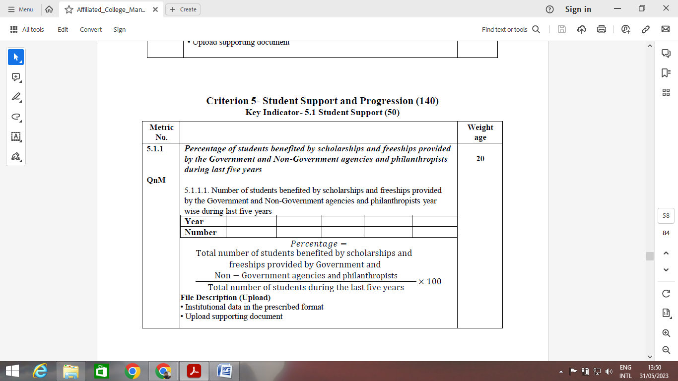

* List of students benefitted (for 2 years)

|  |  |  |  |
| --- | --- | --- | --- |
| **S. No** | **Name of the student** | **Semester** | **Amount Received** |

**5.1.2 Capacity Building**

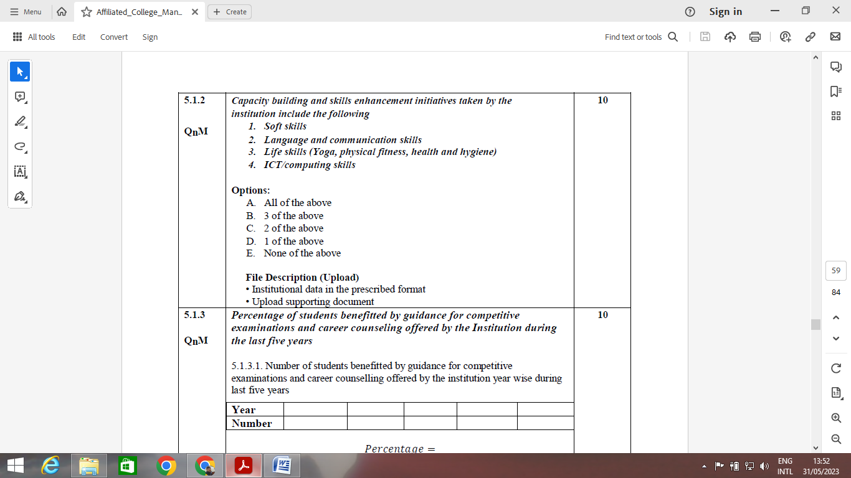

* Details as per table

Year 1

|  |  |  |  |  |
| --- | --- | --- | --- | --- |
| **S No.** | **Name of the Activity** | **Date** | **No. of students enrolled** | **Name of the Agency** |
| 1 | Communication | DD-MM-YY | 252 | OPTUS |
| 2 | Aptitude | DD-MM-YY | 112 | GGITS |
| 3 | Presentation Skills | DD-MM-YY | 242 | GGITS |
| 4 | CV Preparation | DD-MM-YY |  | OPTUS & other company |
|  |  |  |  |  |

Year2, year 3, year 4 and year 5 to be done as per above table

* Syllabus of all the training programs (computer skills, programming skills, soft skills etc)
* Health & hygiene (webinar photos can be attached)
* Yoga Program (photos to be attached)
* Physical fitness program (photos to be attached)
* Excel / Ms office etc can be added as IT skills.
* Photographs can be attached.
* Bridge courses can be added (English) along with attendance sheet.

Year 1

|  |  |  |  |  |
| --- | --- | --- | --- | --- |
| S. No | Type of program | Date | No, of students appeared | Attendance sheet |
|  |  |  |  |  |

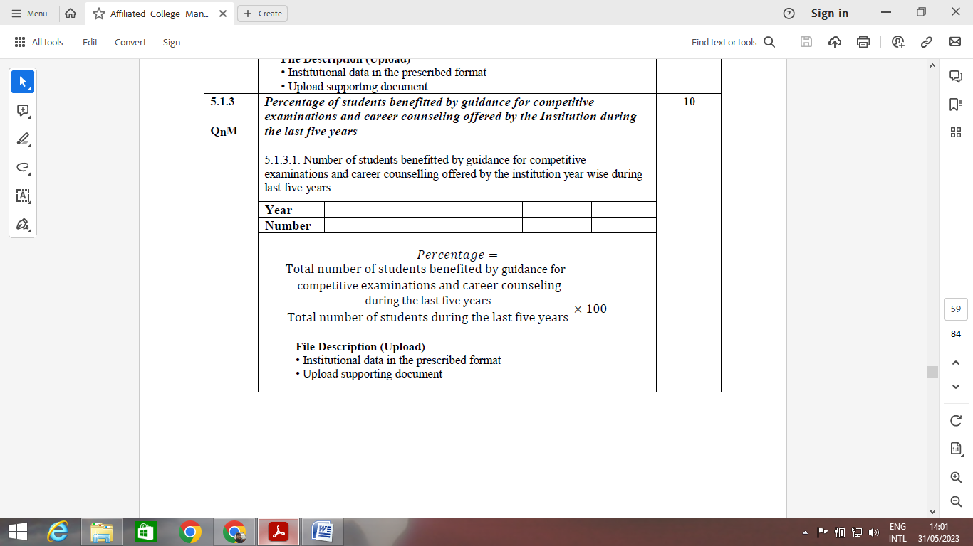

* Fill in the table as per format
* Guidance on Competitive Examination like GATE, GRE, GMAT, TOFEL, IELTS, CAT and any other examination.
* Scanned copy of the circulars (Year wise)
* Career guidance feedback form and analysis.

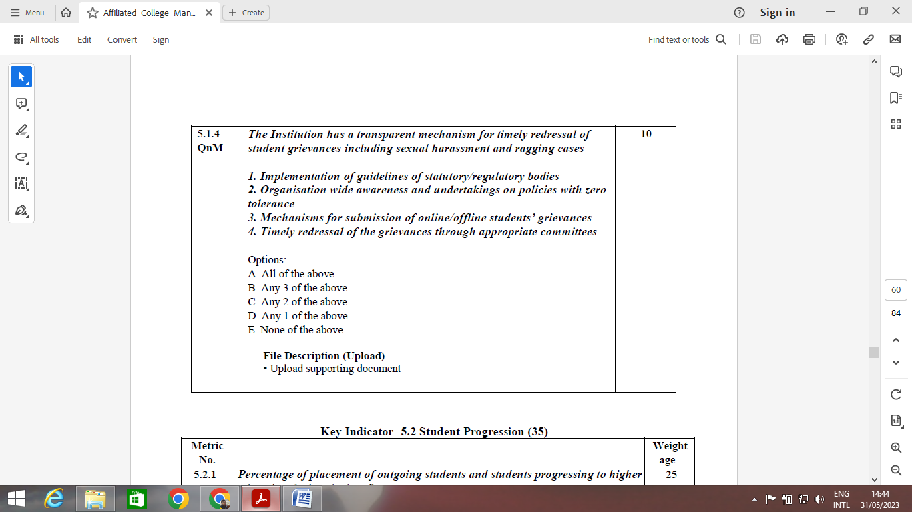

* Committee on Grievance redressal **and** minutes of the meeting
* Awareness programs on sexual harassment etc.
* Grievance Online Application form
* Inclusion of a faculty with mobile number on the website
* Preparation of a report on grievance

|  |  |  |  |  |
| --- | --- | --- | --- | --- |
| **Sr. No.** | **Name of the Expert** | **Title of the program** | **Date** | **No. of students** |
| 1 | Dr. XYZ | Awareness Program on "----" | DD-MM-YY | 242 |

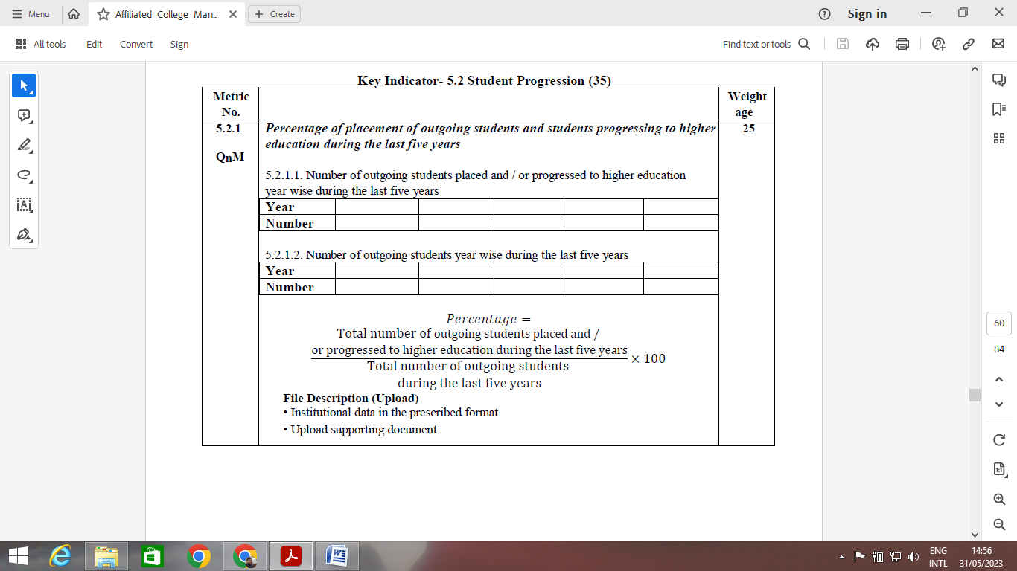

* Fill the data as per format
* Attach sample appointment letters.
* Circular on placements.
* No. of students appeared and no. of students got selected (year wise)

|  |  |  |  |  |
| --- | --- | --- | --- | --- |
| **S No.** | **Name of the Company** | **No. of students appeared** | **No. of students Selected** | **Date** |

* Feedback of the employers

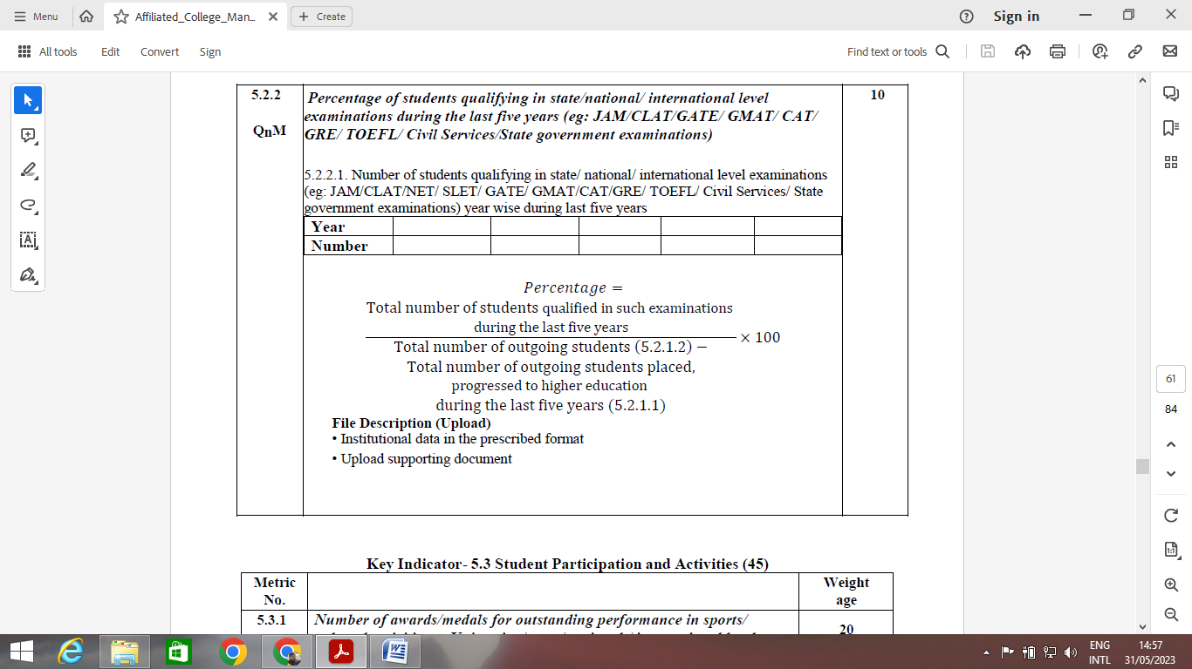

* Fill as per the format
* Attach admission letters

**5.3.1 No. of awards / medals**

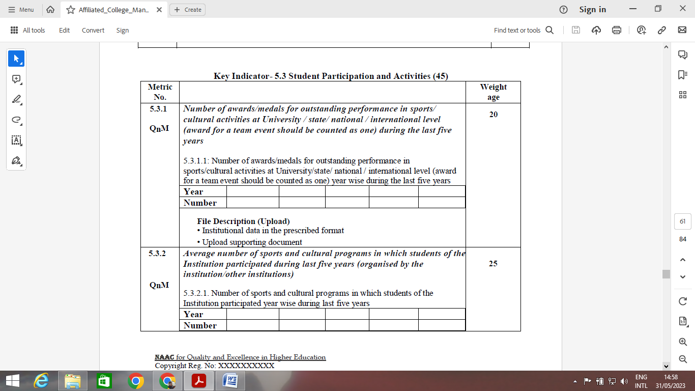

* Fill as per format

**5.3.2 Sports and Cultural Programs**



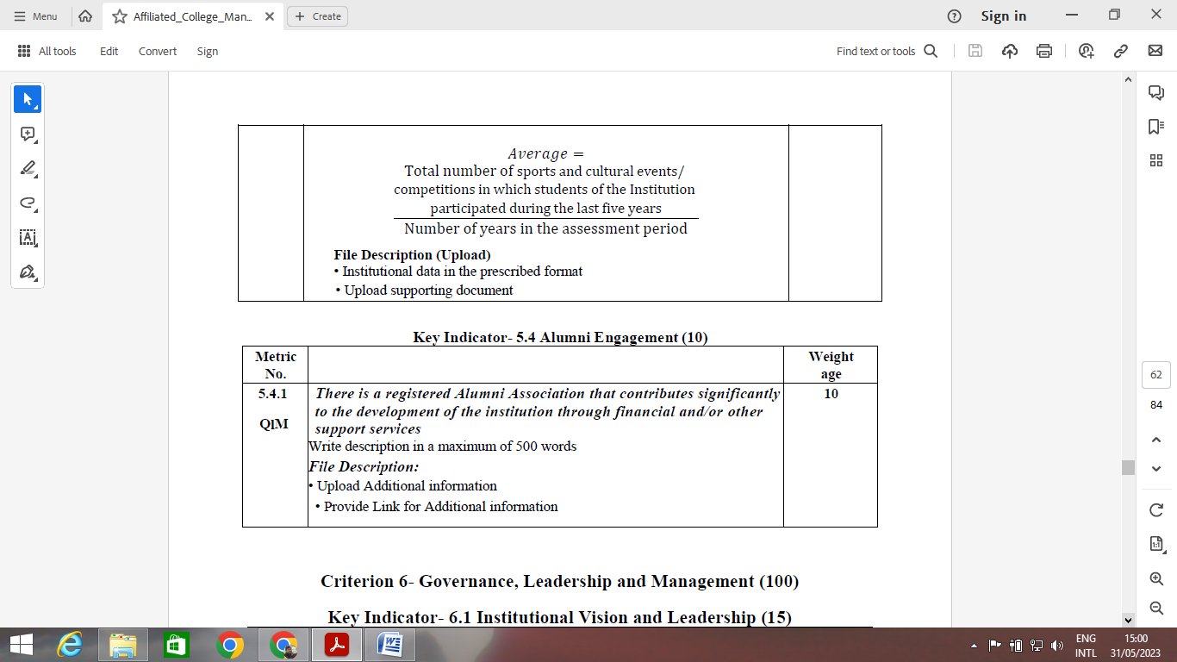

* Fill as per format (year wise)

|  |  |  |  |  |
| --- | --- | --- | --- | --- |
| **S. No.** | **Name of the event** | **Organised by** | **Name of the students appeared** | **Award** |

* Photographs to be attached.

**5.4.1 Alumni engagement**



|  |  |  |  |  |  |
| --- | --- | --- | --- | --- | --- |
| **S. No.** | **Name of the Alumni** | **Regd. NO and address** | **Title of the lecture** | **Date** | **No of students** |

* Alumni day photographs and report on the alumni day
* Program schedule of Alumni Day
* Attendance of Alumni

Alumni day attendance

|  |  |  |  |
| --- | --- | --- | --- |
| S. No | Name of the alumni | Address | Date |
|  |  |  |  |